**Data Analysis on Online news Popularity**

**Abstract:**

As digital media is growing the competition between online platforms also has rapidly increased. Online platforms like Buzzfeed, Mashable, Medium, towards data science publish hundreds of articles of every day. In this report we analyze the Mashable dataset which consists of articles data information mainly as number of unique words, number of non-stop words, positive polarity of words, negative polarity of words etc. Here we intend to predict the number of shares that articles can be shared. This will be very helpful for Mashable to decide which articles should they publish because they can actually predict which articles will be having maximum number of shares. Random forest regression has been used to predict the number of shares and it can achieve an accuracy of 70% with Parameter tuning. As there are number of articles that will be collected from different ways but to classify or group these articles into separate categories for an online platform it will be an difficult job. To handle this problem, in this report we have used neural network to classify the articles into different categories. By doing so, the people doesn’t need to do an extensive search because the Mashable can keep an interface with articles classified into different categories which in-turn will help people to choose the category and directly search their articles.

***Keywords*** – Neural networks classifier, Random forest regression, Parameter tuning, non-stop words

**Introduction:**

With the growing of Internet on daily life, people are in a minute away to read the news or watch any entertainment or read the articles of different categories. As the growth of internet even the usage by the people of it has increased rapidly, it actually became their part of life. Nowadays as the people using the internet more they are studying the articles for their knowledge or news or of any sector from online. As the demand is increased even online platforms rivalry has increased. Due to this every online platform is striving to publish the articles in their site which have a great value and bring most shares. In this project we do prediction of shares of an article based on the data produced by ‘Mashable’ where they collected data of around 39000 articles. For this prediction we have used Random forest Regression. In this report will be discussing why the Random forest Regression has been choose for the prediction of shares by analyzing the Data set and doing cross tabulation, what is the variance of the dataset and how much level of bias it is with-holding. Even discuss about the features selection and why decided to do some feature engineering and how it will be helpful in increasing the accuracy. Even in this report we discuss how these predictions will be helpful for Mashable organization on their decision of publishing the articles.

In this paper we will see to handle the issue of classifying the articles such as entertainment, news, lifestyle, technology etc. To obtain this classification used the neural networks. In this paper we will discuss about why did we choose the neural networks for classification and what type of feature engineering has been used. At what levels of hidden layers and neurons the model is being affected at what stages model got started getting overfitted. For classification after the output layer we used soft-max function. In this paper, a 11 layer neural network classifier has been used and achieved around 80% of accuracy. Methods used to achieve this accuracy is constant check rate of accuracy with different layers and neurons, standardization technique and feature selection using correlation matrix.

Related work on the study and analysis of Online News Popularity is done by the Shuo Zhang[1] from Australian National University where they predicted the article will be popular or not and used binary neural network classification. The other related works which also achieved greater accuracy of 70% but here they actually predicted the shares by applying different regression techniques. This paper was worked by He Ren and Quan Yang work in Department of Electrical Engineering in Stanford University[2].

**Objectives:**

* Predicting the number of shares an article can get it
* Classifying the articles into different categories?
* Which category of article should be published maximum for higher number of shares?
* On What week-day What type of article should Mashable post more?
* For different categories of articles what should be their min and max content length?

**Data set:**

This Dataset mainly consists of heterogenous features about articles published by Mashable in a period of two years. Dataset consists of 39644 rows and 61 columns each column describing about an article length and number of unique words in it, number of positive words, average positive polarity, number of shares. This dataset has been extracted from [UCI machine learning Repository](http://archive.ics.uci.edu/ml/datasets/Online%20News%20Popularity).

**Organization:**

Mashable was early started as a word press blog in 2005 and in very short time Fame came relatively quickly, with Time magazine noting Mashable as one of the 25 best blogs of 2009. Mashable is basically now a digital media platform where every sector articles or videos can be watched and read. Eventually it started even ecommerce now. Nowadays Mashable role in the world is something where any one can grab the information they want and acting as a Social good role for welfare of society and sharing the cultures and posting documentaries.

**Business Needs:**

Being Mashable very famous and it has shined very quickly by 4 years from its started. But around 2014 it has suffered losses and to recover from that they started to analyze the data they have and how could they can attract people to use more of their platform. So they thought to analyze the articles they are collecting from different sources and figured out they need to go up in their business they need to stand out these needs[3]:

* Due to limited of articles they can publish in their platform they thought to publish which will be shared more?
* Needed to classify the articles, blogs and videos into different sectors, so that users don’t need to do an exhaustive search.
* Wanted to keep their scope increase in some sector where most of the users are concentrating or interested to study the articles?

The usage and access, extraction of data has been with some privacy and can effectively used if they are passing with Ziff Davis LLC policy[4]. The data set which we have extracted has been passed from these policies.

**Dataset Schema:**

Dataset used is CSV file. The description of data set is as follows:

0. url: URL of the article.(String)  
1. timedelta: Days between the article publication and the dataset acquisition.(float)  
2. n_tokens_title: Number of words in the title (Integer)  
3. n_tokens_content: Number of words in the content((Integer)  
4. n_unique_tokens: Rate of unique words in the content (Integer)  
5. n_non_stop_words: Rate of non-stop words in the content (Integer)  
6. n_non_stop_unique_tokens: Rate of unique non-stop words in the content(Integer)  
7. num_hrefs: Number of links (Integer)  
8. num_self_hrefs: Number of links to other articles published by Mashable (Integer)

9. num_imgs: Number of images (float)  
10. num_videos: Number of videos (float)  
11. average_token_length: Average length of the words in the content (float)  
12. num_keywords: Number of keywords in the metadata (float)  
13. data_channel_is_lifestyle: Is data channel 'Lifestyle'? (Binary)  
14. data_channel_is_entertainment: Is data channel 'Entertainment'? (Binary)   
15. data_channel_is_bus: Is data channel 'Business'? (Binary)  
16. data_channel_is_socmed: Is data channel 'Social Media'? (Binary)  
17. data_channel_is_tech: Is data channel 'Tech'? (Binary)  
18. data_channel_is_world: Is data channel 'World'? (Binary)  
19. kw_min_min: Worst keyword (min. shares) (float)  
20. kw_max_min: Worst keyword (max. shares) (float)  
21. kw_avg_min: Worst keyword (avg. shares) (float)  
22. kw_min_max: Best keyword (min. shares) (float)  
23. kw_max_max: Best keyword (max. shares) (float)  
24. kw_avg_max: Best keyword (avg. shares) (float)  
25. kw_min_avg: Avg. keyword (min. shares) (float)  
26. kw_max_avg: Avg. keyword (max. shares) (float)  
27. kw_avg_avg: Avg. keyword (avg. shares) (float)  
28. self_reference_min_shares: Min. shares of referenced articles in Mashable (float)  
29. self_reference_max_shares: Max. shares of referenced articles in Mashable (float)  
30. self_reference_avg_sharess: Avg. shares of referenced articles in Mashable (float)  
31. weekday_is_monday: Was the article published on a Monday? (Binary)  
32. weekday_is_tuesday: Was the article published on a Tuesday? (Binary)  
33. weekday_is_wednesday: Was the article published on a Wednesday? (Binary)  
34. weekday_is_thursday: Was the article published on a Thursday? (Binary)  
35. weekday_is_friday: Was the article published on a Friday? (Binary)  
36. weekday_is_saturday: Was the article published on a Saturday? (Binary)  
37. weekday_is_sunday: Was the article published on a Sunday? (Binary)  
38. is_weekend: Was the article published on the weekend? (Binary)  
39. LDA_00: Closeness to LDA topic 0 (float)  
40. LDA_01: Closeness to LDA topic 1 (float)  
41. LDA_02: Closeness to LDA topic 2 (float)  
42. LDA_03: Closeness to LDA topic 3 (float)  
43. LDA_04: Closeness to LDA topic 4 (float)  
44. global_subjectivity: Text subjectivity (float)  
45. global_sentiment_polarity: Text sentiment polarity (float)  
46. global_rate_positive_words: Rate of positive words in the content (float)  
47. global_rate_negative_words: Rate of negative words in the content (float)  
48. rate_positive_words: Rate of positive words among non-neutral tokens (float)  
49. rate_negative_words: Rate of negative words among non-neutral tokens (float)  
50. avg_positive_polarity: Avg. polarity of positive words (float)  
51. min_positive_polarity: Min. polarity of positive words (float)  
52. max_positive_polarity: Max. polarity of positive words (float)  
53. avg_negative_polarity: Avg. polarity of negative words (float)  
54. min_negative_polarity: Min. polarity of negative words (float)  
55. max_negative_polarity: Max. polarity of negative words (float)  
56. title_subjectivity: Title subjectivity (float)  
57. title_sentiment_polarity: Title polarity (float)  
58. abs_title_subjectivity: Absolute subjectivity level (float)  
59. abs_title_sentiment_polarity: Absolute polarity level (float)  
60. shares: Number of shares (target) (Integer)

**Dataset Pre-Processing:**

In this Dataset we had no missing values and no Duplicate values and a little bit about description our dataset is shown in below figure:

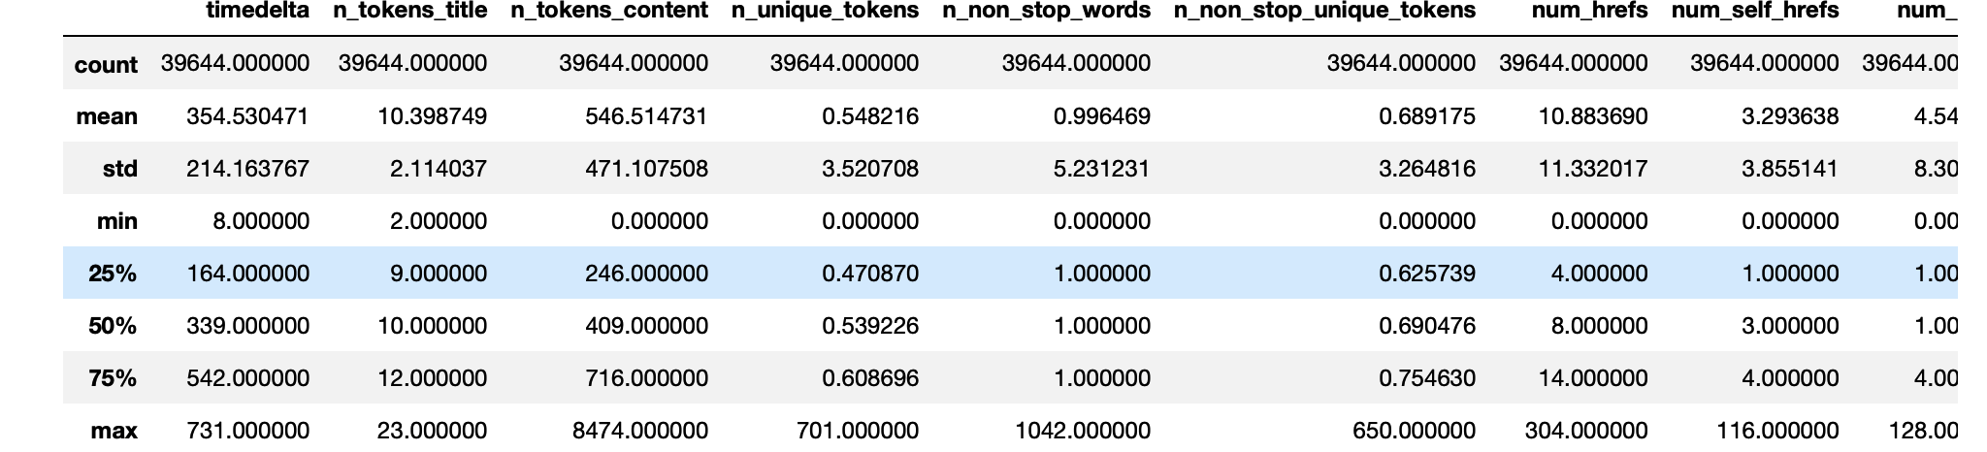

The above figure we can see about the Descriptive statistics of some columns.

**System Architecture:**

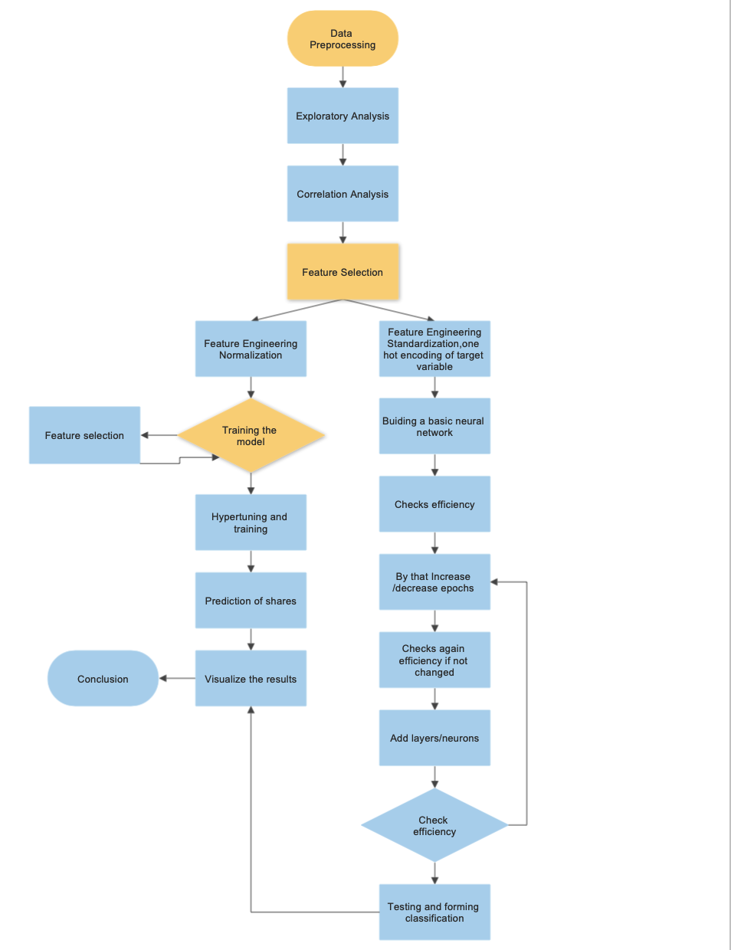

**Data Pre-Processing:**

As early in Data Preprocessing we analyzed that our data has no missing values and no duplicate values but we have some outliers which has been found out in or Exploratory analysis. But processing the data for our 2 models has been different. For Model1 there is no change in data as we have the whole data in numerical so need not to be having a one hot encoding but as the range of the data in different columns in very variance manner we will perform normalization which we will discuss in our later section of report.

But in Second model where we need to classify the articles into different categories we have choosed neural networks and need to change the every different categories into one category and needed to perform one hot encoded which will finally placed into a vector of one column.

Then we performed cross-tabulation of every category in our data set and found out the distribution of categories in our data set. The below table shows the number of articles placed in each category:

|  |  |
| --- | --- |
| Category | Number of articles in that category |
| World | 8427 |
| technology | 7346 |
| Social media | 2323 |
| Entertainment | 7057 |
| Lifestyle | 2099 |
| Business | 6258 |

As we can observe the data classification if categories with Social media and life style has less variety of assumptions. We are dropping time delta and Url which is metadata of articles which won’t be any use in our regression model.

**Exploratory Analysis:**

Now we will plot some graphs with some features which are very essential to select our regression algorithm and will be helpful in deciding why did we choose Neural Networks for classification.

Density Distribution of Shares:

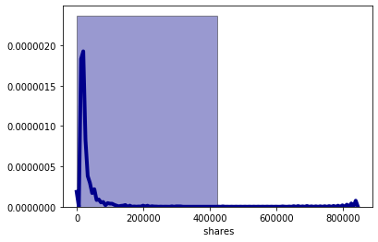

The above graph represents the density distribution of shares in our whole dataset. As we can see we have maximum examples of shares between 0-10,000 shares and gradually decreased with the number of shares increasing. We can actually consider that the shares which are above 20,000 as outliers but in our project these are considered as anomalies. As our project says about the maximum of shares of an article if the article has been shared the most of the time then the features of article has been so peculiar that it has reached maximum of shares. So considering anomality condition we are not classifying these peculiar data as outliers but as anamolies.

Tokens Vs Images:

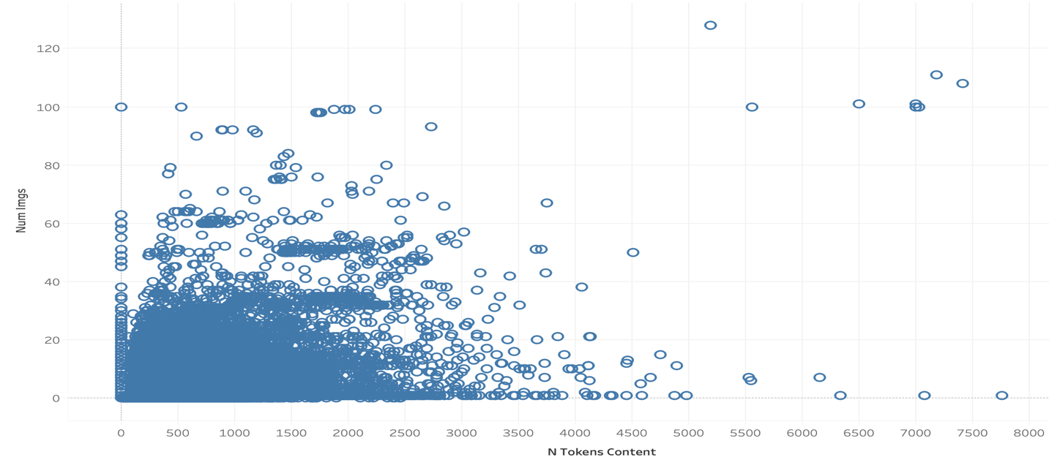

From the above Analysis we are able to Analyze that for what token lengths the number of images should be more. By observing the above graph we can say that till min of 2000 tokens or words we need to have minimum of 30 images and gradually the increase in tokens we need to increase in images so that people who are reading these articles have more **understanding in a visualizing way.**

Token length Vs Shares:

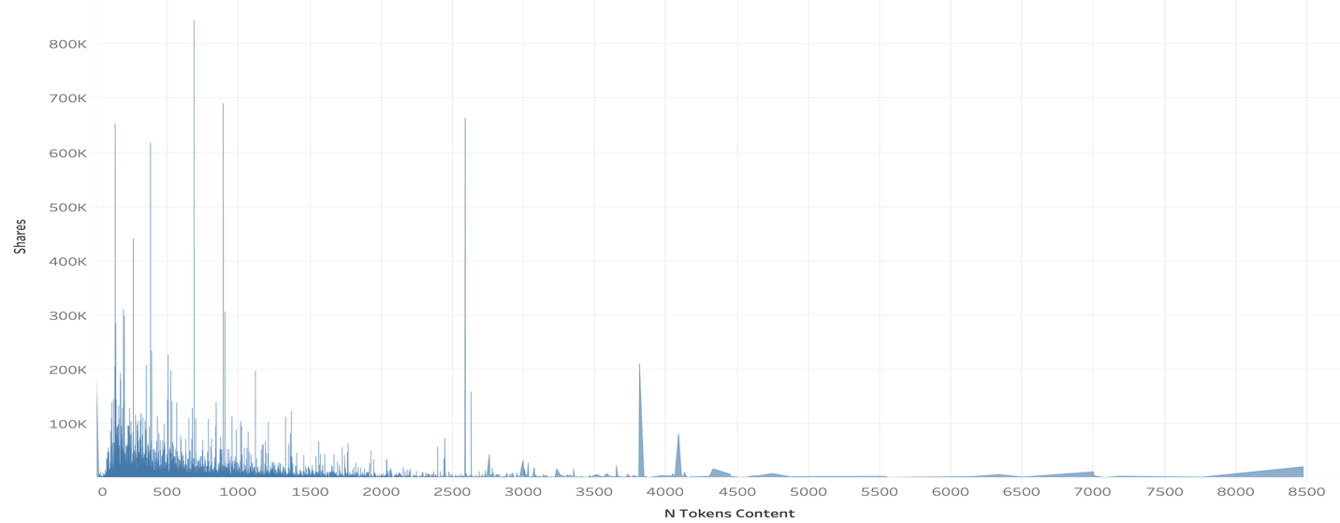

Plotted this graph is mainly to analyze at what token length or at what length of articles the people are liking the articles and shared most. By observing the above graph we can actually say that people are reading the short articles most and shared a lot and the other one are very length article who has more 2000 tokens has been read and shared a lot. By this we can understood that users are of two types who are concentrating on the content and the other are who are just observing what their need is presented in article in a straight-forward manner.

**Pearson-Correlational Analysis:**

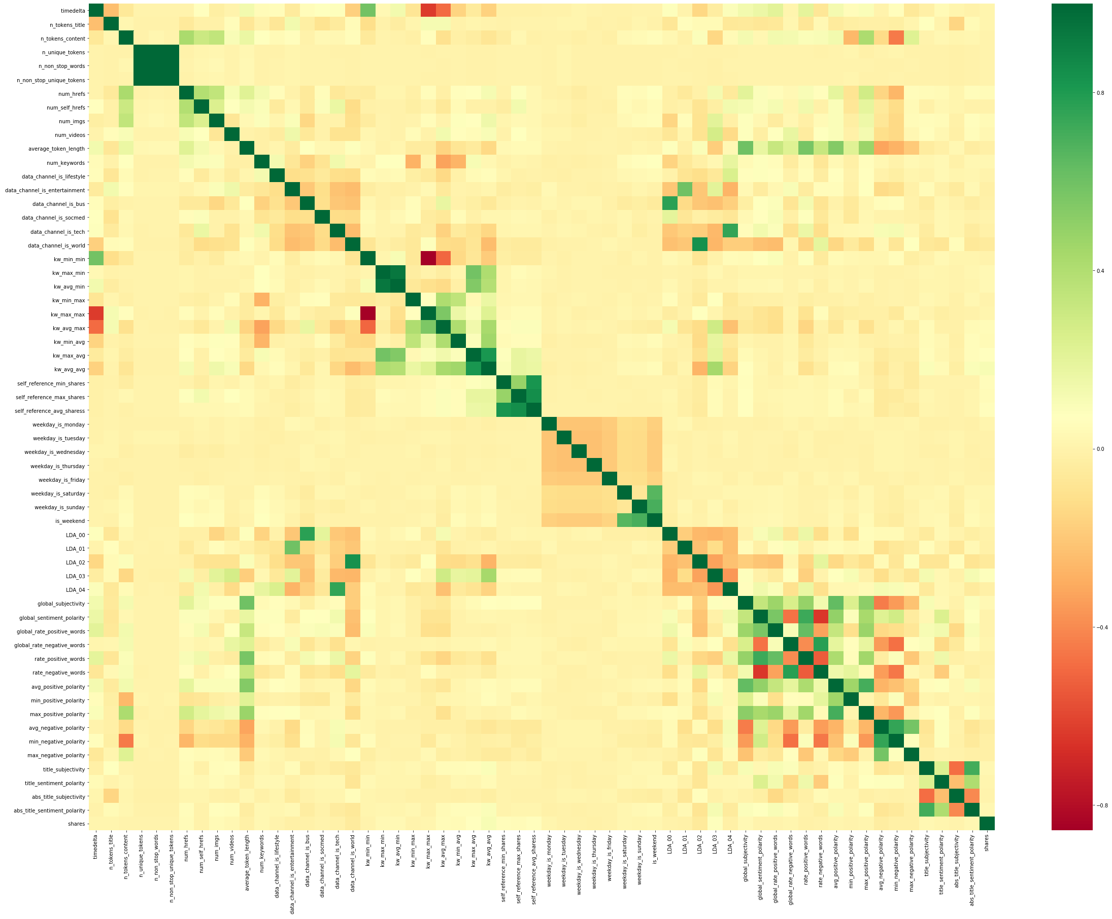

By the above Pearson correlation graph we can say that number of unique words and number of non-stop-words and number of non-stop-unique tokens are strongly correlated which implies that they are strongly linearly dependent on each other. Same as the above case Kw-avg- min and kw-max-min are also strongly corelated.

**Feature Selection:**

By the above correlation graph we can clearly say that these features:

* number of unique words and number of non-stop-words and number of non-stop-unique tokens
* Kw-avg- min and kw-max-min

These are strongly correlated and linearly dependent which makes us to assume that these features are so linearly dependent that any one of the strong correlated feature can be used and excluding the other features won’t affect the model and will be indirectly helpful in our model by not allowing to do overfitting.

**Data Analytics Algorithms:**

The Data Analytics has been done in two parts Model-1 and Model-2 in our report as we need to Regression and Classification tasks.

**Model-1:**

**Selection Of Model:**

For this project we have choose Random forest Regression as our Model. Because as we observed in Data Preprocessing we had Low bias and by Descriptive Statistics we had observed High variance of data and above that we have some anomalies which we need to consider and handle it. By considering the above all conditions we have selected Random forest regression as predicting our shares.

**Splitting of Data Set:**

As we have low bias of data which means less assumptions of data we are splitting our data into 2 parts but not in 3 parts. So in model-1 we are splitting our data as training dataset for 80% and remaining as test dataset for 20%.

**Training 1st time:**

Training data with random forest regression with default parameters we are achieving the Root mean Squared error as 9817.7964.

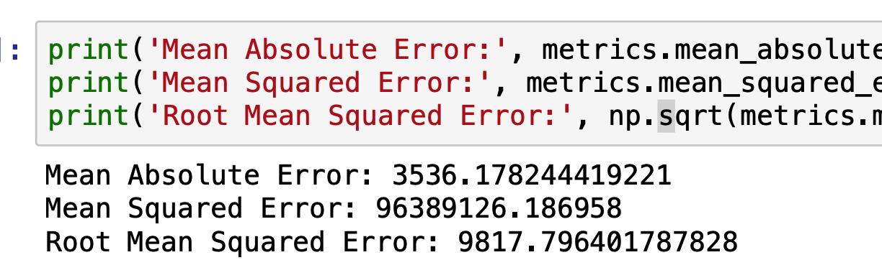

Then we have again performed selection of features by using importance and plotted the first 45 important features as below:

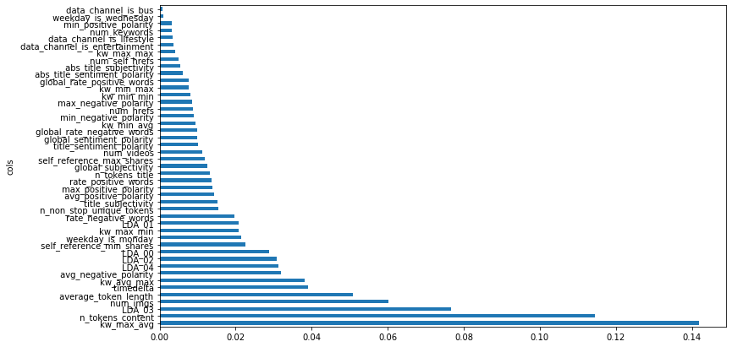

By considering the above important features we ran the model again and performed the Testing again then again we got the same RMSE error implying that the removed features has no effect on the model. But still RMSE error is too high. So we performed Feature Engineering to decrease this error.

**Feature Engineering:**

As we observe the data set we can clearly state that data values in the data set are varied so much and we have some even binary values . To handle this type we have normalized the whole data set so that all column ranges have been normalized to 0-1 range.

**Training and Hyper Tuning of Parameters:**

After performing feature engineering we train our model and evaluate our model with different min samples split which has been done by keeping in the loop and recorded the Root mean square error value. The below figure give us at what min_samples_split we get our efficient model that is less RMSE.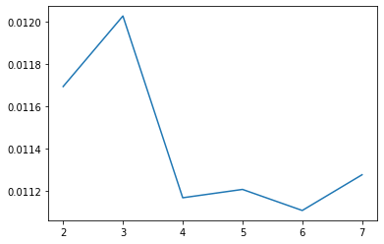

By above figure it is clear that at Min_samples_split the RMSE error is very less after that it started increasing again implying us that at 6 we get our efficient model . Performing at 6 and test our data set we get the RMSE error as follows.

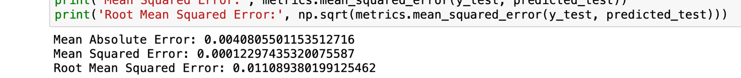

**Model-2:**

For this Dataset we have splitted the dataset into 2 one is training which has 70% of our data and remaining is 30% as test dataset.

The second model is about classification of articles by analyzing the heterogenous features of articles. As we have high dimensionality and high variance of data it was decided that the multiclassification if done by Neural Networks will be more efficient one.

Here we basically transformed the target variable into one hot encoded vector array. Initially we have used 5 hidden layers and 800,400,600,200,200 as their neurons respectively. The activation function used is ‘relu. And in last layer we had performed softmax function. Basically we used soft max function so that we get the outputs as probability of being that class. So once we get the probability value of being that class we take maximum from that vector and assume it has one and all others as Zero. The assuming one which is having one value specifying that it belongs to that particular class. Then we evaluate our predicted value with our original values and perform classification accuracy.

And performed with 10,000 epochs but then we were able to achieve only 27% accuracy.

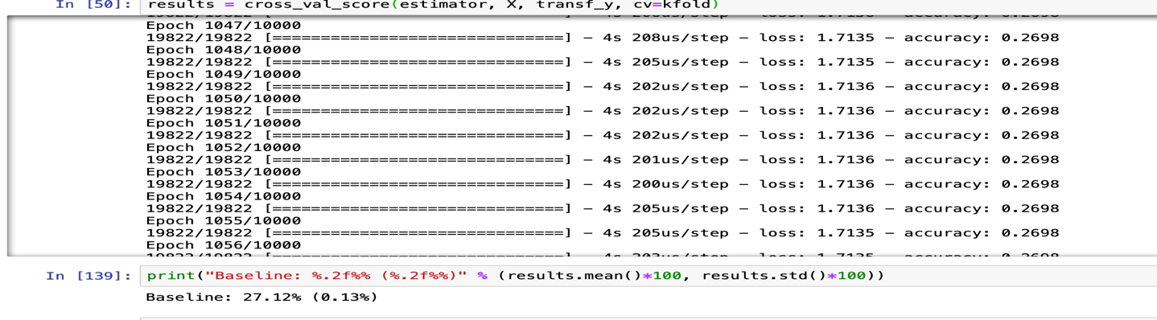

Even after different epochs the accuracy was not able to increased it has stayed as same implying us to add more layers and neurons. So after many trials we have got some stability at around 11 layers.

Final architecture of Neural Network classifier:

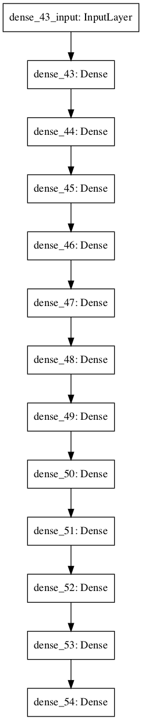

**Feature Scaling:**

So we have performed standardization to our whole data set and tried again this time we have increased 5 to 11 hidden layers and when we observe at different epochs we found out that After around 400 epochs the training classification accuracy is starting to drop gradually showing that increasing more of these epochs the model is getting overfitted. As even we are having more layers our solution got converged very fastly. And in below we can see that training accuracy is very high at 92 epochs but due to overfitting of model when we evaluate with our test data set our accuracy is 78%. It is clearly specifying us that model is overfitted and not able to predict for new test data.

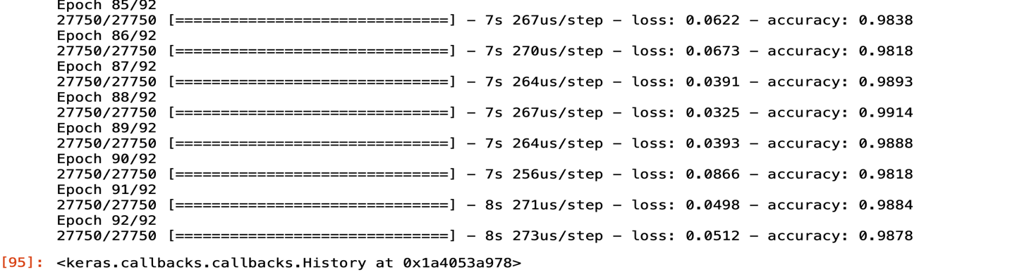

So we again set our epochs to around 21 because their training accuracy is around 90% ,and executed our model and validated with our test data set we have achieved 80% accuracy.

So basically we got a output

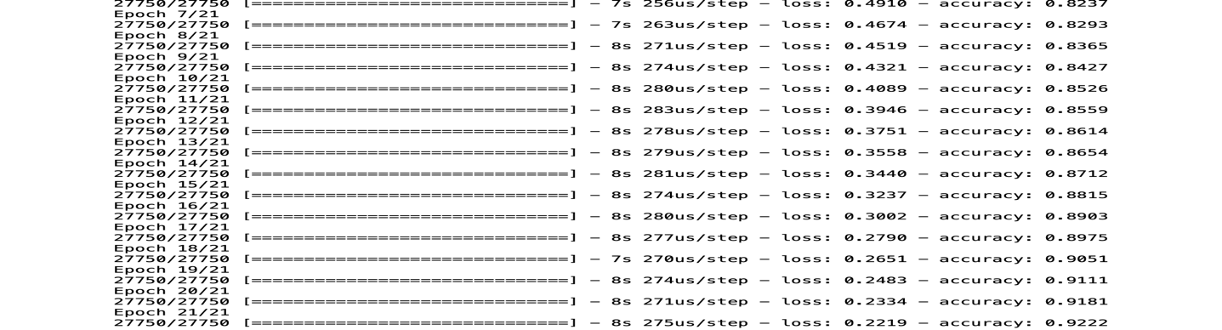

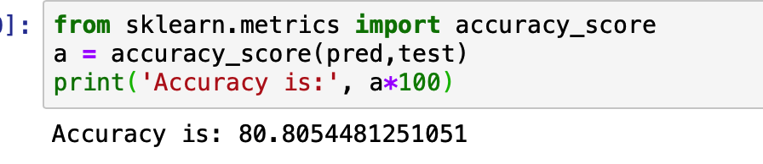

**SW/HW Development Platforms:**

* Jupyter Notebook python
* Tableau for visualization
* Python Packages: Keras and Tensor flow.

**Interpreting the Results:**

* By performing the above 2 models a digital media platform can actually predict the amount of shares does an article get before publishing which will help them to scrape the other articles.
* It also helps the digital platforms organizations to categorize their articles when they extracted it from different sources and have no clue, in which sector does this article belong, So by our model-2 it will be very helpful for them to categorize these articles saving around a lot of manual labor time which can be put for more efficient purposes.

By the usage of above 2 models of prediction of shares and classification of articles the following things can be answered which will be very helpful for Mashable organization:

* By the below figure Mashable can actually interpret that it needs to publish very less articles on Lifestyle and publish more on social media and technology articles.



* By the below plot we can actually decide for maximum popularity of news what should be the minimum token lengths at each sector . Because many of users doesn’t like to read long articles and in some cases they like to if we observe in other category the users like to read short articles as we go for technology there averagely people are okay to read even long articles. This helps the Mashable Organization to decide for which sectors what should be their max and min token lengths for more shares or more popularity.



**Conclusion:**

By analyzing the online news popularity dataset the prediction of shares has achieved the expected output by using random forest regression. Articles category classification using Neural Networks has achieved 80% of accuracy which helped us to group the articles and gave us a conclusion that most of the readers in Mashable are of social media which actively participate and also of in technology sector. So Mashable needs to concentrate on producing the articles more on these sectors at the same time they need to publish the articles of the other categories with a threshold article length not more than 2000 words.

**Lessons Learned:**

Bringing value from a heavy data set. How does this value will be helpful to Organizations. Analyzing the large volumes of data and how to bring the values from it. Correlating the features and calculating the predictability power to the target variable which we are predicting. Selection of different Machine Learning algorithms and their compatibility. Neural Networks works efficient for high dimensional data sets but Needed a very high computational time.

**Further Study:**

Scraping these articles and forming the datasets which has more value by using NLP and need to understand the Linear discriminant analysis which will help us in Dimensionality reduction. Mainly need to focus on scraping the articles and need to predict whether the article has a positivity or negativity and classify them which will actually help us.

**Definitions:**

* Machine learning: Machine learning is the scientific study of algorithms and statistical models that computer systems use to perform a specific task without using explicit instructions, relying on patterns and inference instead. It is seen as a subset of artificial intelligence.
* Neural Networks: Neural networks are a set of algorithms, modeled loosely after the human brain, that are designed to recognize patterns. They interpret sensory data through a kind of machine perception, labeling or clustering raw input.
* Random Forest Regression:Random forests or random decision forests are an ensemble learning method for classification, regression and other tasks that operates by constructing a multitude of decision trees at training time and outputting the class that is the mode of the classes (classification) or mean prediction (regression)
* Standardization: Data standardization is the process of rescaling one or more attributes so that they have a mean value of 0 and a standard deviation of 1. Standardization assumes that your data has a Gaussian (bell curve) distribution.
* Epochs: an arbitrary cutoff, generally defined as "one pass over the entire dataset", used to separate training into distinct phases, which is useful for logging and periodic evaluation. So, in other words, a number of epochs means how many times you go through your training set.
* Normalization:Normalization is a technique often applied as part of data preparation for machinelearning. The goal of normalization is to change the values of numeric columns in the dataset to a common scale, without distorting differences in the ranges of values.

# Works Cited

Ali, E. (n.d.). *medium*. Retrieved from deep learning using Keras: https://towardsdatascience.com/building-a-deep-learning-model-using-keras-1548ca149d37

Davis, Z. (n.d.). *LLC privacy policy*. Retrieved from https://www.ziffdavis.com/privacy-policy

Mashable. (n.d.). Retrieved from http://inseaddataanalytics.github.io/INSEADAnalytics/groupprojects/January2017/MashableNews.html

ren, H. (n.d.). *cs229 standford*. Retrieved from Predicting and Evaluating the Popularity of Online News: http://cs229.stanford.edu/proj2015/328_report.pdf

renu. (n.d.). *medium*. Retrieved from building neural networks: https://medium.com/datadriveninvestor/building-neural-network-using-keras-for-classification-3a3656c726c1

sadiq, s. (n.d.). *medium*. Retrieved from https://medium.com/@syedsadiqalinaqvi/predicting-popularity-of-online-news-articles-a-data-scientists-report-fac298466e7

tanvar, S. (n.d.). *medium* . Retrieved from Buidling first neural network in keras: https://towardsdatascience.com/building-our-first-neural-network-in-keras-bdc8abbc17f5

wikipedia. (n.d.). *Mashable*. Retrieved from wikipedia: https://en.wikipedia.org/wiki/Mashable

zhang, s. (n.d.). *Online News Popularity Prediction*. Retrieved from http://users.cecs.anu.edu.au/~Tom.Gedeon/conf/ABCs2018/paper/ABCs2018_paper_167.pdf

1. (zhang, n.d.)
2. (ren, n.d.)
3. (wikipedia, n.d.)
4. (Davis, n.d.)